**Mike's requested spread factor [2.25, 1.7, 1.2, .75, .25]**

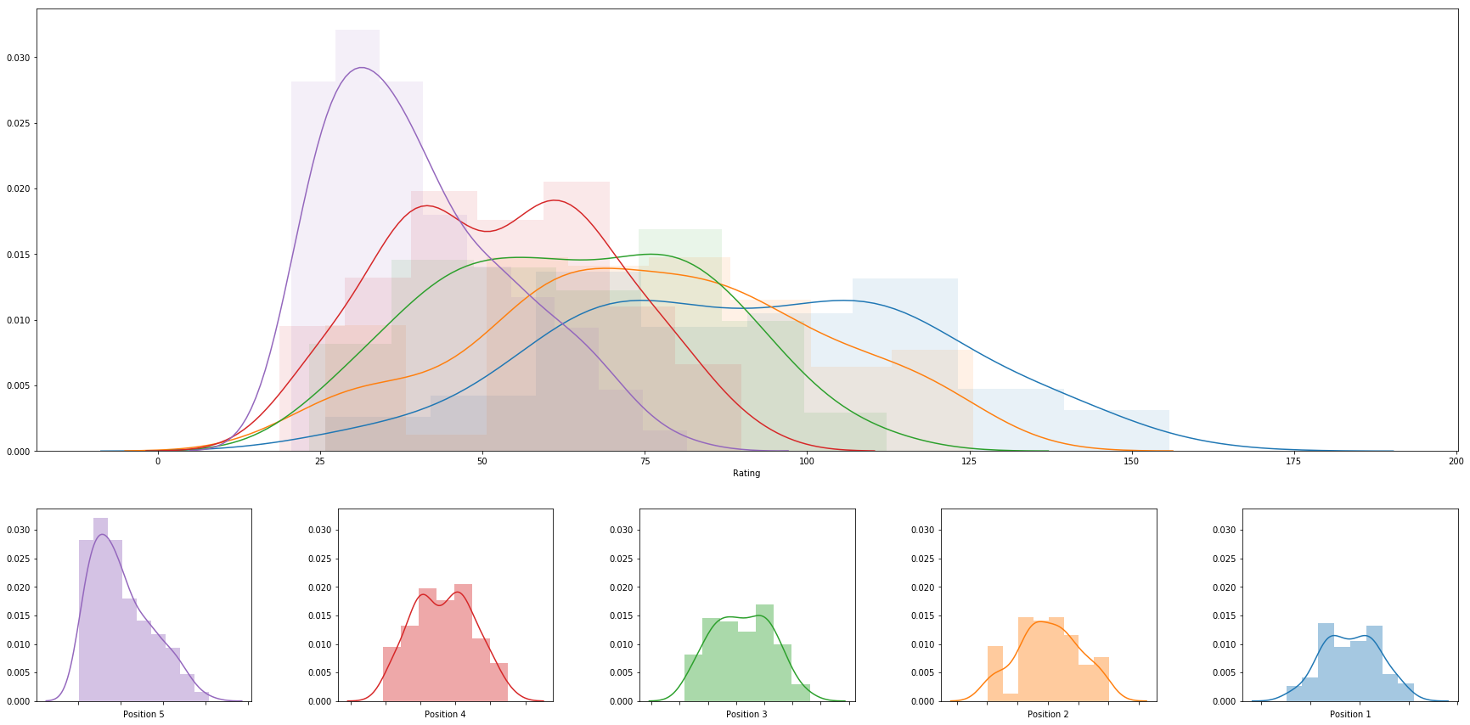

|  |  |  |  |  |  |  |  |
| --- | --- | --- | --- | --- | --- | --- | --- |
|  | **rank** | **name** | **college** | **division** | **rating** | **primary position** | **date** |
| **0** | 1 | Abril Bustamante | USC | DI | 155.77076574724447 | 1 | 2018-05-05 |
| **1** | 2 | Emily Maglio | Hawaii | DI | 142.74106773954966 | 1 | 2018-05-06 |
| **2** | 3 | Ka'iwi Schucht | Hawaii | DI | 142.74106773954952 | 1 | 2018-05-06 |
| **3** | 4 | Nicole McNamara | UCLA | DI | 142.26137265102736 | 1 | 2018-05-06 |
| **4** | 5 | Megan McNamara | UCLA | DI | 142.26137265102733 | 1 | 2018-05-06 |
| **5** | 6 | Victoria Paranagua | Florida State | DI | 139.75827797826506 | 1 | 2018-05-05 |
| **6** | 7 | Tina Graudina | USC | DI | 138.3339799311933 | 1 | 2018-05-05 |
| **7** | 8 | Claire Coppola | LSU | DI | 135.5382557724672 | 1 | 2018-05-04 |
| **8** | 9 | Kristen Nuss | LSU | DI | 135.5382557724672 | 1 | 2018-05-04 |
| **9** | 10 | Vanessa Freire | Florida State | DI | 132.29810224124674 | 1 | 2018-05-05 |
| **10** | 11 | Sasha Karelov | Long Beach State | DI | 129.8987446793367 | 1 | 2018-04-28 |
| **11** | 12 | Nele Barber | Long Beach State | DI | 129.68914878156266 | 1 | 2018-04-28 |
| **12** | 13 | Kaylie Mchugh | Tulane | DI | 129.27277526929674 | 1 | 2018-04-21 |
| **13** | 14 | Madeline Mertz | Tulane | DI | 129.27277526929674 | 1 | 2018-04-21 |
| **14** | 15 | Teegan Van Gunst | Georgia State | DI | 125.86620817422234 | 1 | 2018-04-21 |
| **15** | 16 | Katie Smith | South Carolina | DI | 125.54725247436043 | 2 | 2018-05-04 |
| **16** | 17 | Rachel Nieto | Long Beach State | DI | 121.02087278910416 | 2 | 2018-04-28 |
| **17** | 18 | Annika Van Gunst | Georgia State | DI | 120.97865819746269 | 1 | 2018-04-21 |
| **18** | 19 | Sunny Villapando | Stanford | DI | 120.85672944489383 | 1 | 2018-04-27 |
| **19** | 20 | Mima Mirkovic | Cal | DI | 120.54903686013951 | 1 | 2018-04-28 |
| **20** | 21 | Margherita Bianchin | FIU | DI | 120.51987441298579 | 1 | 2018-05-04 |
| **21** | 22 | Federica Frasca | FIU | DI | 120.51987441298579 | 1 | 2018-05-04 |
| **22** | 23 | Morgan Martin | Hawaii | DI | 120.13214635821274 | 2 | 2018-05-06 |
| **23** | 24 | Deahna Kraft | Pepperdine | DI | 119.80648086229971 | 2 | 2018-05-05 |
| **24** | 25 | Corinne Quiggle | Pepperdine | DI | 119.80648086229971 | 2 | 2018-05-05 |
| **25** | 26 | Aeriel Horton | Houston Baptist | DI | 118.9474292083636 | 1 | 2018-04-22 |
| **26** | 27 | Jessica Wooten | Houston Baptist | DI | 118.9474292083636 | 1 | 2018-04-22 |
| **27** | 28 | Sarah Sponcil | UCLA | DI | 118.89135203958902 | 2 | 2018-05-06 |
| **28** | 29 | Lily Justine | UCLA | DI | 118.89135203958902 | 2 | 2018-05-06 |
| **29** | 30 | Terese Cannon | USC | DI | 117.40379128579596 | 2 | 2018-05-05 |
| **30** | 31 | Lea Monkhouse | Hawaii | DI | 117.35292028127054 | 2 | 2018-05-06 |
| **31** | 32 | Sammy Slater | USC | DI | 117.30204728229276 | 2 | 2018-05-05 |
| **32** | 33 | Katie Horton | Florida State | DI | 116.71264178857088 | 2 | 2018-05-05 |
| **33** | 34 | Dani Barton | Utah | DI | 115.50648710430669 | 1 | 2018-04-27 |
| **34** | 35 | Adore Anae | Utah | DI | 115.50648710430669 | 1 | 2018-04-27 |
| **35** | 36 | Alexia Inman | Cal | DI | 114.70801319544357 | 1 | 2018-04-28 |
| **36** | 37 | Hailey Luke | Florida State | DI | 114.09932486973884 | 2 | 2018-05-05 |
| **37** | 38 | Tia Miric | Cal Poly SLO | DI | 113.24923794259958 | 1 | 2018-04-28 |
| **38** | 39 | Torrey Van Winden | Cal Poly SLO | DI | 113.24923794259958 | 1 | 2018-04-28 |
| **39** | 40 | Madalyn Roh | Pepperdine | DI | 113.0045772116626 | 1 | 2018-05-05 |
| **40** | 41 | Brook Bauer | Pepperdine | DI | 113.0045772116626 | 1 | 2018-05-05 |
| **41** | 42 | Ali Denney | South Carolina | DI | 112.90628753582153 | 1 | 2018-05-04 |
| **42** | 43 | Shannon Williams | South Carolina | DI | 112.90628753582153 | 1 | 2018-05-04 |
| **43** | 44 | Haleigh Nelson | LSU | DI | 112.30055991148465 | 2 | 2018-05-04 |
| **44** | 45 | Carly Kan | Hawaii | DI | 112.24863494543371 | 3 | 2018-05-06 |
| **45** | 46 | Natalie Anselmo | Arizona | DI | 112.10958602062462 | 1 | 2018-04-27 |
| **46** | 47 | Olivia Macdonald | Arizona | DI | 112.1095860206246 | 1 | 2018-04-27 |
| **47** | 48 | Kimmy Gardiner | Washington | DI | 110.50276514720382 | 1 | 2018-04-28 |
| **48** | 49 | Jordan Anderson | Washington | DI | 110.50276514720382 | 1 | 2018-04-28 |
| **49** | 50 | Cadie Bates | South Carolina | DI | 109.62251339275005 | 2 | 2018-05-04 |
| **50** | 51 | Morgan Hughes | Saint Mary's | DI | 109.44054722946413 | 1 | 2018-04-21 |
| **51** | 52 | Payton Rund | Saint Mary's | DI | 109.44054722946413 | 1 | 2018-04-21 |
| **52** | 53 | Laurel Weaver | Hawaii | DI | 109.21374321342064 | 3 | 2018-05-06 |
| **53** | 54 | Emily Sonny | Cal Poly SLO | DI | 108.88793415986028 | 2 | 2018-04-28 |
| **54** | 55 | Jessica Gaffney | Cal | DI | 108.33670813588567 | 2 | 2018-04-28 |
| **55** | 56 | Nicole Lott | UNC Wilmington | DI | 107.888107922109 | 1 | 2018-04-21 |
| **56** | 57 | Maddy Kline | UNC Wilmington | DI | 107.888107922109 | 1 | 2018-04-21 |
| **57** | 58 | Darby Dunn | Stetson | DI | 107.57657988747954 | 1 | 2018-04-21 |
| **58** | 59 | Sammee Thomas | Stetson | DI | 107.57657988747954 | 1 | 2018-04-21 |
| **59** | 60 | Sara Putt | Florida State | DI | 106.96110384032261 | 3 | 2018-05-05 |
| **60** | 61 | Sam Manley | Cal Poly SLO | DI | 106.43757839253496 | 2 | 2018-04-28 |
| **61** | 62 | Savannah Slattery | LMU | DI | 106.42114507901674 | 1 | 2018-04-21 |
| **62** | 63 | McKayla Ferris | LMU | DI | 105.83989383499532 | 1 | 2018-04-21 |
| **63** | 64 | Destiny Julye | Washington | DI | 105.34670573650676 | 2 | 2018-04-28 |
| **64** | 65 | Amelia Smith | Stanford | DI | 105.33944971358561 | 2 | 2018-04-27 |
| **65** | 66 | Morgan Hentz | Stanford | DI | 105.33944971358558 | 2 | 2018-04-27 |
| **66** | 67 | Cassie House | TCU | DI | 105.15545908365202 | 1 | 2018-04-15 |
| **67** | 68 | Haven Hill | TCU | DI | 105.15545908365202 | 1 | 2018-04-15 |
| **68** | 69 | Kenley Adams | UAB | DI | 105.09494171205046 | 1 | 2018-04-21 |
| **69** | 70 | Devon May | UAB | DI | 105.02727781207412 | 1 | 2018-04-21 |
| **70** | 71 | Molly Turner | Grand Canyon | DI | 105.02262558488925 | 1 | 2018-04-19 |
| **71** | 72 | Courtney Schwan | Washington | DI | 104.97306270823799 | 2 | 2018-04-28 |
| **72** | 73 | Tiffany Creamer | Georgia State | DI | 104.57791801611577 | 2 | 2018-04-21 |
| **73** | 74 | Iya Lindahl | Cal | DI | 101.77422843887979 | 2 | 2018-04-28 |
| **74** | 75 | Hannah Towne | Grand Canyon | DI | 101.59690597511751 | 1 | 2018-04-19 |
| **75** | 76 | Megan Kruidhof | Long Beach State | DI | 101.38870037646745 | 2 | 2018-04-28 |
| **76** | 77 | Macy Jerger | Florida State | DI | 101.02540106351935 | 3 | 2018-05-05 |
| **77** | 78 | Carly Scarborough | FAU | DI | 100.82923932682571 | 1 | 2018-04-21 |
| **78** | 79 | Jessie Prichard | LMU | DI | 100.07814102332091 | 2 | 2018-04-21 |
| **79** | 80 | Savvy Simo | UCLA | DI | 99.70075664477606 | 3 | 2018-05-06 |
| **80** | 81 | Brooke Weiner | Georgia State | DI | 99.5508077979559 | 2 | 2018-04-21 |
| **81** | 82 | Sara Kovac | LMU | DI | 99.13088570387663 | 2 | 2018-04-21 |
| **82** | 83 | Courtney Bowen | Stanford | DI | 99.07262780700992 | 3 | 2018-04-27 |
| **83** | 84 | Emily Bible | Saint Mary's | DI | 98.74672656943949 | 2 | 2018-04-21 |
| **84** | 85 | Lindsey Knudsen | Saint Mary's | DI | 98.74672656943949 | 2 | 2018-04-21 |
| **85** | 86 | Hunter Domanski | LSU | DI | 97.44321345159533 | 3 | 2018-05-04 |
| **86** | 87 | Katja Ehlers | College of Charleston | DI | 97.0295173727133 | 1 | 2018-04-21 |
| **87** | 88 | Lan Nguyen | Tulane | DI | 96.33225856865039 | 2 | 2018-04-21 |
| **88** | 89 | Carly Perales | Stetson | DI | 96.12290989303158 | 2 | 2018-04-21 |
| **89** | 90 | Sunniva Helland-Hansen | Stetson | DI | 96.12290989303156 | 2 | 2018-04-21 |
| **90** | 91 | Haley Hallgren | USC | DI | 95.35833904642982 | 3 | 2018-05-05 |
| **91** | 92 | Tarin Mergener | Tulane | DI | 95.07677414076059 | 2 | 2018-04-21 |
| **92** | 93 | Amanda Silva | FAU | DI | 94.80736003016897 | 1 | 2018-04-21 |
| **93** | 94 | Carly Dehoog | Washington | DI | 94.34216789098835 | 3 | 2018-04-28 |
| **94** | 95 | Shayne Mcpherson | Washington | DI | 94.34216789098835 | 3 | 2018-04-28 |
| **95** | 96 | Georgia Johnson | Georgia State | DI | 94.16619522063888 | 3 | 2018-04-21 |
| **96** | 97 | Courtney Miller | UNF | DI | 94.13615533471093 | 1 | 2018-04-21 |
| **97** | 98 | Carina Hoff | UNF | DI | 94.13615533471093 | 1 | 2018-04-21 |
| **98** | 99 | Joy Dennis | USC | DI | 93.78246344549738 | 3 | 2018-05-05 |
| **99** | 100 | Krissy Mummey | College of Charleston | DI | 93.46137072138994 | 1 | 2018-04-21 |